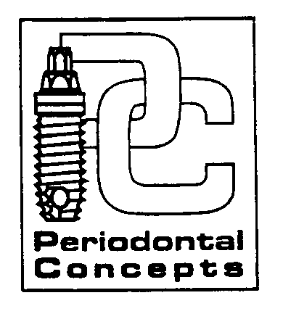

Instructions following PERIODONTAL Scaling and Root Planing

- Definition: Scaling and Root Planing (SRP) is a type of periodontal therapy. It removes harmful bacteria and deposits deep within the periodontal pockets around the teeth. Root planing cleans and detoxifies the root surfaces to encourage reattachment of the supportive tissues.

- Mouth Rinses: You may want to rinse your mouth with warm salt water after each meal unless you are on a salt restricted diet. This will help to soothe the gum tissues and also promotes healing. Use ½ teaspoon salt to 8 oz. of water. You may also use a mouthwash if preferred.

- Bleeding: You may notice some blood clotting between your teeth for 24-48 hours following SRP, this is normal. You may rinse with warm water, salt water, brush or floss to remove. DO NOT however use fingernails, toothpicks etc. as this can damage the tissues.

- HOMECARE: A clean mouth heals faster. Plaque is always forming on your teeth and gums, it needs to be removed each day. Brush at least twice a day and floss at least one time per day. Use all other aides as directed.

- DIET: Eat whatever feels comfortable. This will be different for each patient. No hot beverages until the numbness is completely worn off.

- PAIN RELIEVER: You may experience some postoperative discomfort. You may want to take pain medication such as Tylenol or Ibuprofen prior to the anesthetic wearing off. This will help alleviate postoperative discomfort associated with scaling and root planing.

- NUMBNESS: You may be numb for an additional 1-3 hours following treatment. You may experience some tingling or itching as the anesthetic is wearing off. This is normal and can be alleviated by taking a pain reliever prior to the discomfort. Avoid eating during this time as you may bite your cheek or tongue.

- SENSITIVITY: You may experience increased sensitivity to hot/cold temperatures following the procedure. The sensitivity should decrease within 6-8 weeks. You may want to switch to a sensitivity protection toothpaste such as Sensodyne. If the sensitivity persists, we can recommend a prescription fluoride toothpaste to aid w/ the sensitivity.

If you have any problems or questions regarding your healing, contact our office Tuesday thru Friday
8am-4pm.

Periodontal Concepts-Cascade Park
300 SE 120th Ave., # 500
Vancouver, WA 98683
360-254-8151 Fax 360-254-7175
www.periodontalconcepts.net

